Accelerated SAP (ASAP) Implementation Methodology

Accelerated SAP Project Phases Detail Description

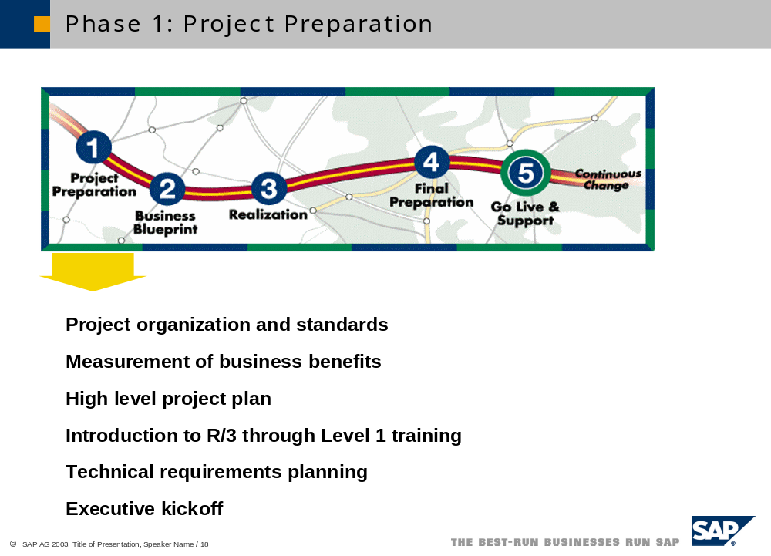

During this initial Project Preparation phase, the project team is finalized and trained in the ASAP roadmap, a high-level project plan is completed, and the hardware order is reviewed. The project is officially started with an Executive Kickoff. The Executive Kickoff is attended not only by the project team and the SAP consultants but also by other key members of Katz. This kickoff sets the stage for the project by highlighting the importance of the project to the overall business goals and the commitment to the project from the executive team.

Critical deliverables of the Project Preparation phase are:

- Project and Resource Plan
- Implementation Strategy
- Training Plan
- Project Standards and Procedures
- Project Quality Plan
- Technical Requirements in particular Hardware Sizing

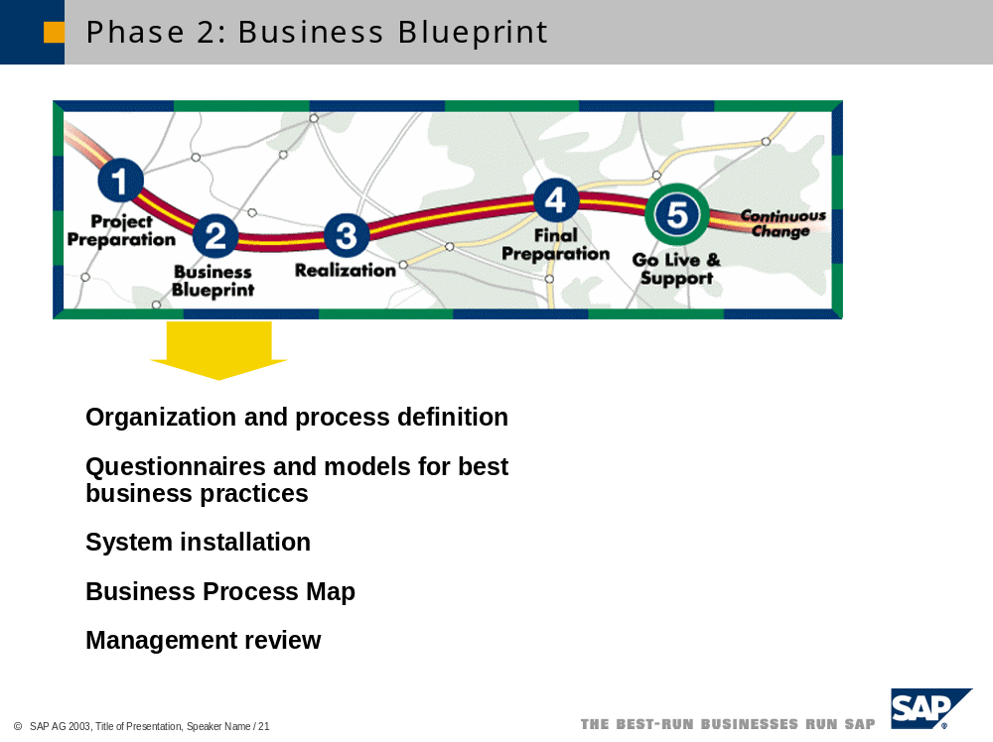

The purpose of this second phase, Business Blueprint, is to understand the business goals of Katz and to determine the business processes required to support those goals. An executive overview meeting will be held to discuss the business goals, organizational structure and the high-level business processes. More detailed requirements will be discussed during separate workshops to discuss each business process. The SAP consultants will conduct the executive overview and the business processes review sessions. To verify that a proper understanding of Katz’s requirements have been communicated, a “blueprint” of Katz’s future state will be prepared and presented to Katz for approval. This blueprint will consist of a pictorial view of Katz’s organizational structure as well as a first draft definition of Katz’s business processes both written and in pictorial format. This blueprint will finalize the detailed scope of the project.

Critical deliverables of the Business Blueprint phase are:

- Business Blueprint in particular Project Scope, Organization Structure, Business Process Maps and Documentation and a Gap Analysis
- Refined Project Plan
- End User Training and Documentation Plan
- Test Plans including critical activities, Integration Testing and Cutover/Dry Run Testing

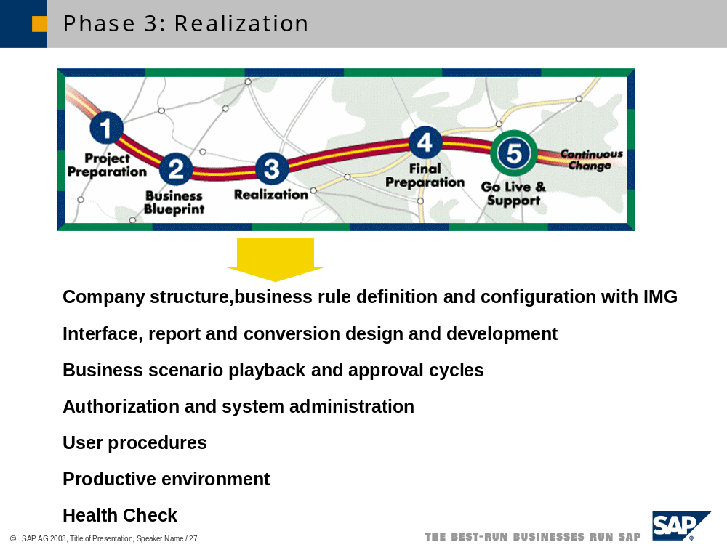

The SAP consultants will complete the baseline configuration of the business processes identified in the above blueprint. The configured system will reflect Katz’s organization and master data as well as support a fully integrated process flow through the system. A playback of Katz’s business processes to both the project team as well as other key users of each business process allow for feedback as well as further confirmation of the blueprint.

The baseline configuration evolves to the future state model developed into an integrated and documented solution that fulfills Katz’s business and process requirements.

To this end, the configuration of each core business process will be divided into iterations or cycles of related business process flows. The business process flows are configured in concert with the development of reports, user procedures, testing scenarios and security profiles. The cycles not only provide milestones for the project team but also provide checkpoints to test and “playback” specific parts of the overall business process. This approach provides immediate feedback as well as involves the entire organization throughout the project life cycle.

During the configuration cycles, Katz’s project team will be working one on one with the SAP consultants to further define specific business scenarios and exception conditions. This approach allows for maximum knowledge transfer by allowing the project team to repeat the configuration of core business processes while also fine tuning the system to account for common business scenarios.

In a parallel activity, conversion, interface and report programs are developed and tested.

SAP feels that testing, such as unit, module and integration testing is critical throughout the Realization phase. SAP strongly recommends a best practice in utilizing the Computer Aided Testing Tool (CATT) that is part of the ABAP Workbench. This simple but powerful tool will allow Katz’s project team to create test scenarios that can be repeated as part of the larger scenario or integration. Experience has demonstrated that CATT has another useful purposes such as, the loading of setup (master) data as part of cutover. CATT is a standard part of the SAP software.

Critical deliverables of the Realization phase are:
- Configured and Tested Solution Ready for Final Preparation
- Integration Test
- Conversion Programs Tested
- Authorization Profiles
- Training Documentation
- Knowledge Transfer
- System Test Plans
- Cutover Plan

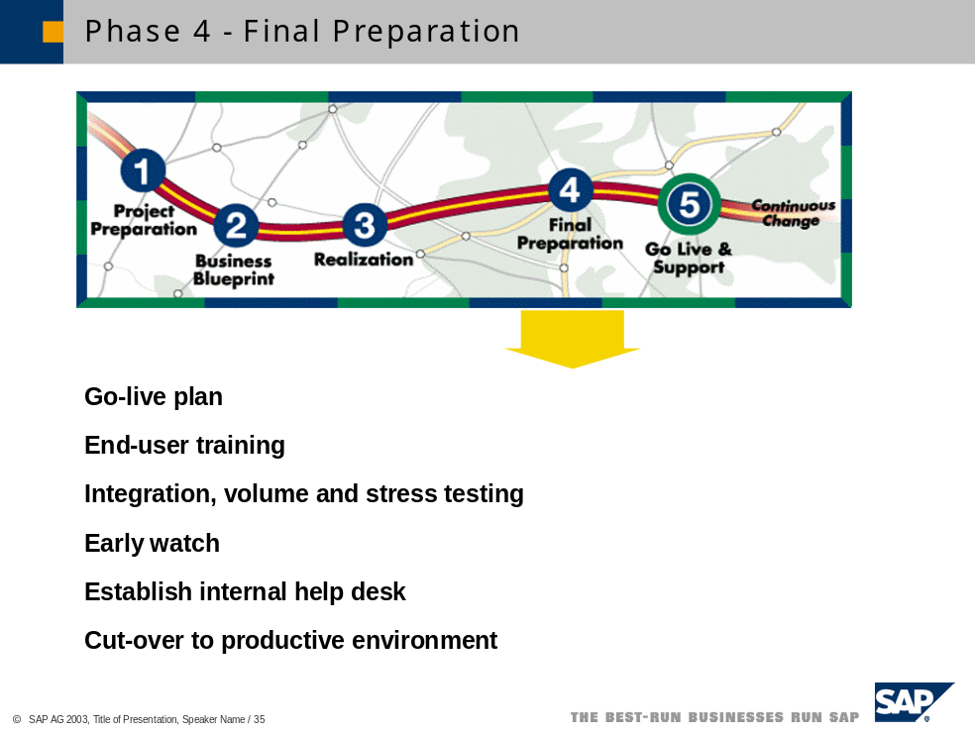

The primary purpose of this fourth phase, Final Preparation, is to complete final system testing, train end-users and cut over both the data and the system to a production environment. Final system testing consists of testing conversion procedures and programs, testing interface programs, conducting volume and stress testing and conducting final user acceptance testing.

To train end-users, the project team will train key users utilizing a train-the-trainer method. SAP understands that Katz wishes to have the team leads responsible for end user training, SAP agrees that this method will help gain acceptance by the end-user community and also build the knowledge base for self-support.

Another purpose of this phase is to create a Go-Live strategy. This plan specifically identifies the data conversion strategy, initial audit procedures and a project team support structure.

The final step in this phase is to approve the system and the readiness of the company to go live and to officially turn on the SAP system.

Critical deliverables of the Final Preparation phase are:
- Cut-over Plan
- Cut Over Test Plan
- End User Training
- System Test, Volume and Stress Testing
- Post Go Live Procedures
- CCC (Customer Competency Center) Sustainment Organization
- Knowledge Transfer

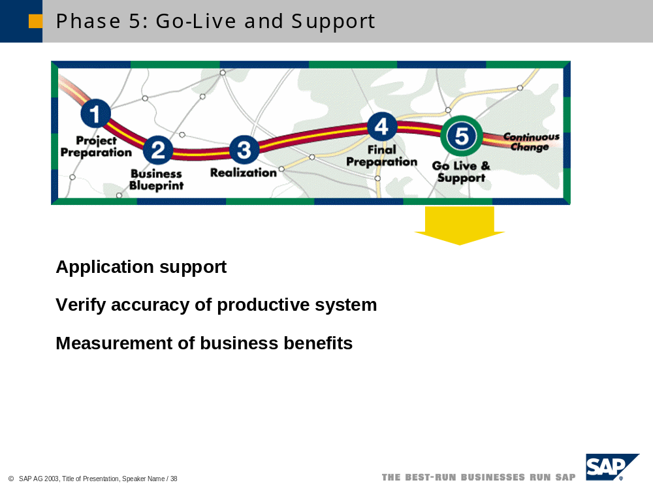

Immediately after going live, the system must be reviewed and refined to ensure that the business environment is fully supported. This process involves not only verifying the accuracy of the business transactions but also informally interviewing the user community to verify their needs are being met. The last step in the process involves measuring the business benefits of the new system.

On an ongoing basis, the power and flexibility of SAP can now be realized in support of ongoing process improvements. The system can continue to be rolled out to additional levels, access to data in support of decision-making can be proliferated and use of additional features can be achieved in a controlled manner.

Critical deliverables of the Go-Live phase are:
- Production Support
- CCC Operational
- Complete Knowledge Transfer
- Final Project Reports

Critical Success Factors

The mere nature of an accelerated implementation indicates a shortened timeframe and the need to progress at a rapid pace. The following list outlines the key critical success factors needed in an ASAP project:

- Executive sponsorship
- Full-time Project Team
- Empowered team
- Adaptable organization
- Defined business direction
- Ability to make decisions quickly

Summary

The following diagram identifies each phase of SAP’s ASAP implementation methodology and respective deliverables.
